**COMPUTER PROJECT 2**

**MECE 744- Non Linear Controls**

**a)**

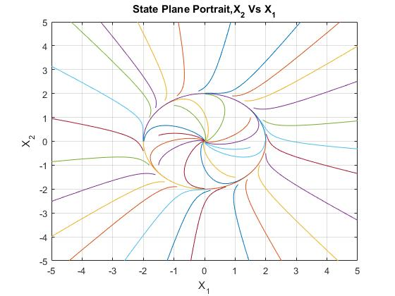

**Figure 1:** State Plane Portrait (X2 Vs X1)

**B)**

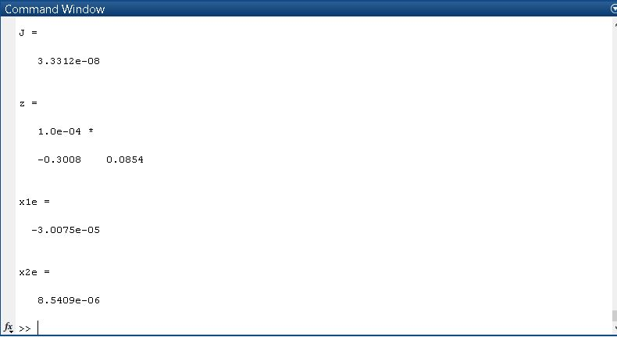

**Figure 2:** Matlab Command Window showing the Equilibrium Points found using “fminsearch”

Here x1e is the equilibrium point for X1 and x2e is the equilibrium point for X2. “J” is the final cost function value.

**C)**

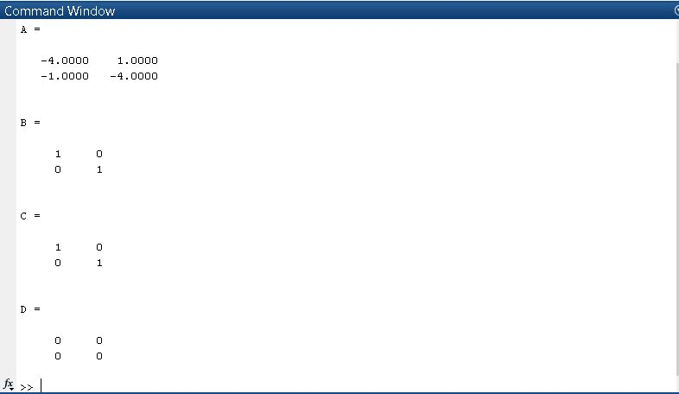

**Figure 3:** Matlab Command Window showing the linearized state-space model obtained using “linmod”

**d)**

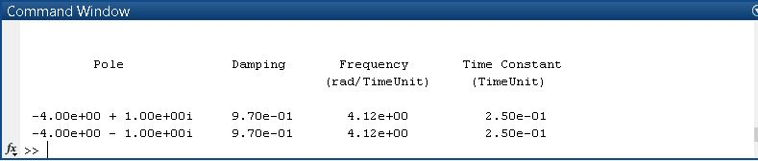

**Figure 4:** Eigen Values, damping ratios and natural frequency for the Linearized state-space model

The Eigen values and the damping ratios have no units and are constants. The natural frequency has units of rad/sec and the time constant has units of secs.

**e)**

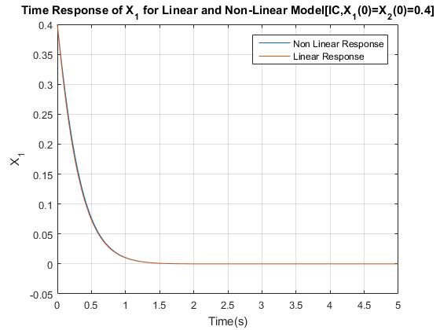

**Figure 5:** Linear and Non Linear Responses of X­1 for IC (X1=X2=0.4)

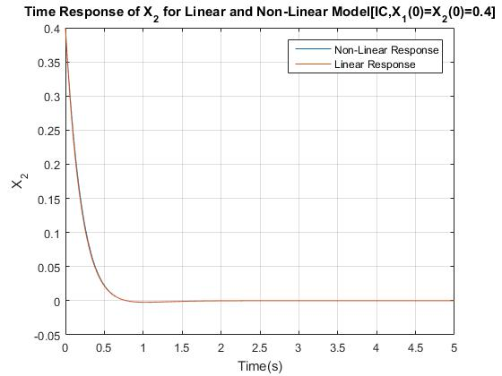

**Figure 6:** Linear and Non Linear Responses of X­2 for IC (X1=X2=0.4)

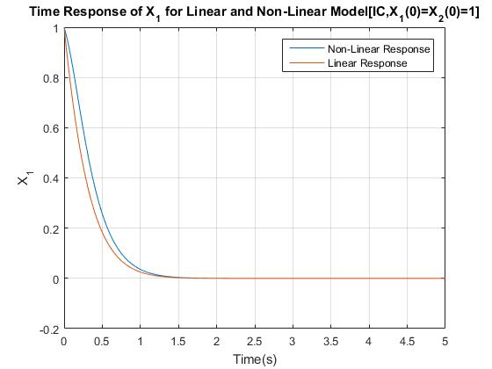

**Figure 7:** Linear and Non Linear Responses of X­1 for IC (X1=X2=1)

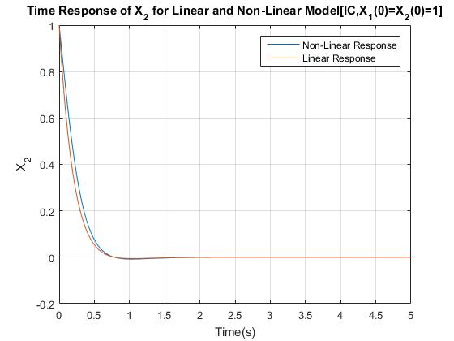

**Figure 8:** Linear and Non Linear Responses of X­2 for IC (X1=X2=1)

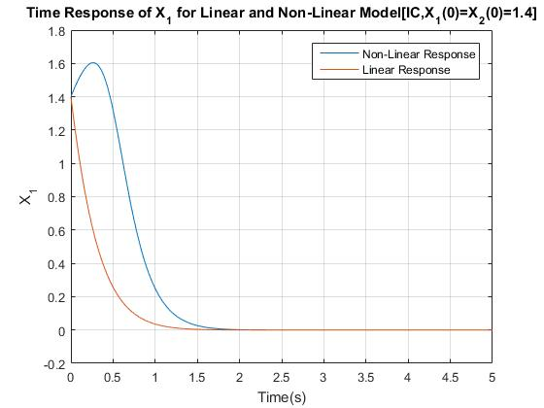

**Figure 9:** Linear and Non Linear Responses of X­1 for IC (X1=X2=1.4)

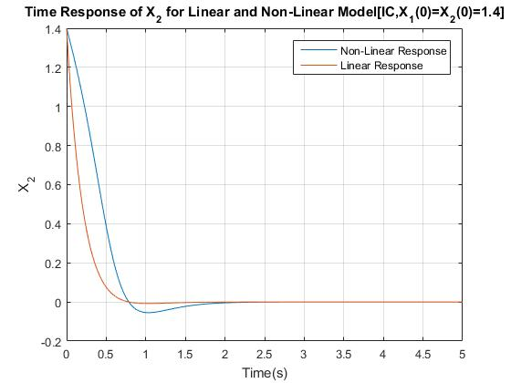

**Figure 10:** Linear and Non Linear Responses of X­2 for IC (X1=X2=1.4)

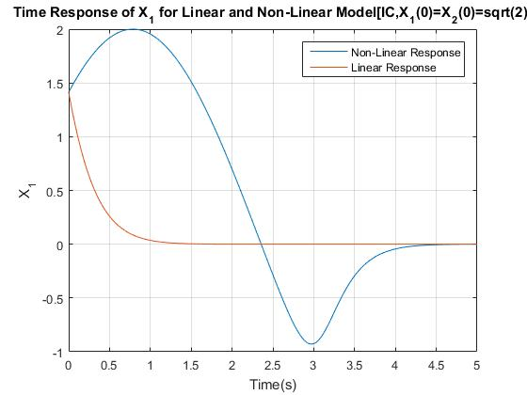

**Figure 11:** Linear and Non Linear Responses of X­1 for IC (X1=X2=√2)

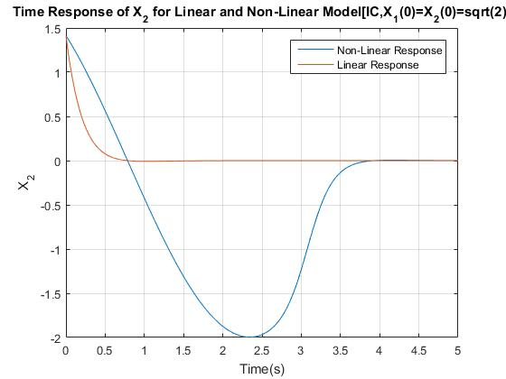

**Figure 12:** Linear and Non Linear Responses of X­2 for IC (X1=X2=√2)

SIMULINK DIAGRAMS

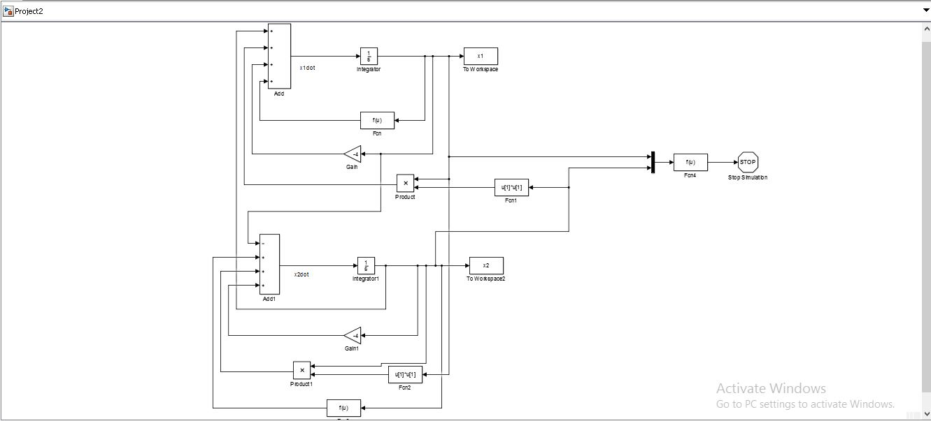

**Figure 13:** Simulink Diagram for the given Non-Linear System

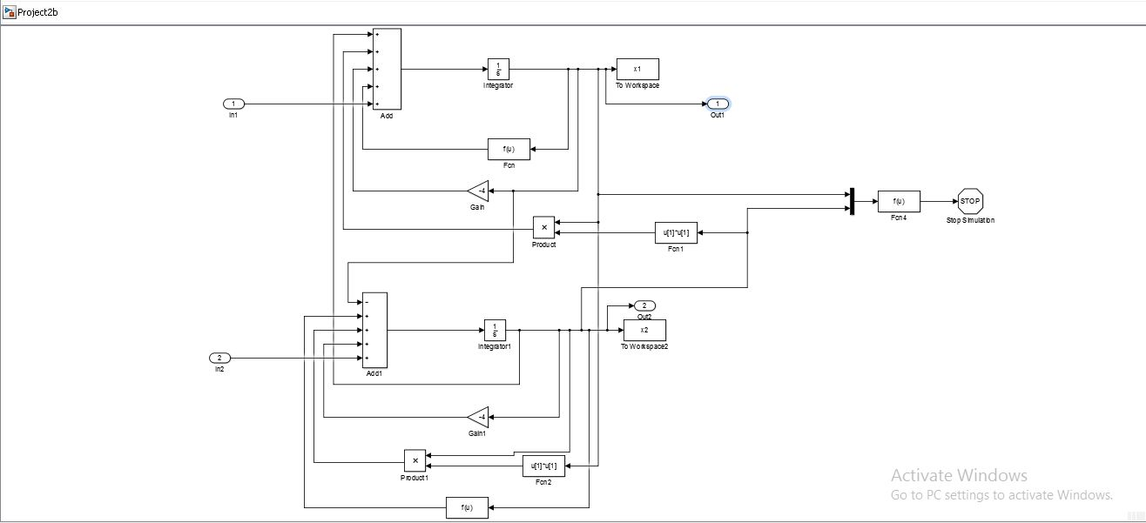

**Figure 14:** Simulink Diagrams used for “linmod” function showing the input and output ports

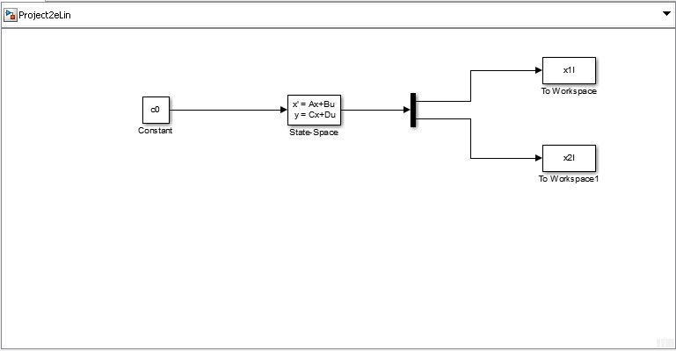

**Figure 15: Linearized State- Space Simulink Model for the given Non-Linear System**

**MATLAB CODE**

%%Computer Project 2

%%Code by K S Adarsh Raj

%%Part A: Phase Plane Portrait

%Defining 39 Initial Conditions and saving the data

%define the 1st intial conditions

x10=0;

x20=2;

%call the simulation

sim('Project2');

%save the data

x11=x1;

x21=x2;

%define the 2nd intial conditions

x10=2;

x20=0;

%call the simulation

sim('Project2');

%save the data

x12=x1;

x22=x2;

%define the 3rd intial conditions

x10=0;

x20=-2;

%call the simulation

sim('Project2');

%save the data

x13=x1;

x23=x2;

%define the 4th intial conditions

x10=-2;

x20=0;

%call the simulation

sim('Project2');

%save the data

x14=x1;

x24=x2;

%define the 5th intial conditions

x10=0;

x20=1.98;

%call the simulation

sim('Project2');

%save the data

x15=x1;

x25=x2;

%define the 6th intial conditions

x10=1.98;

x20=0;

%call the simulation

sim('Project2');

%save the data

x16=x1;

x26=x2;

%define the 7th intial conditions

x10=0;

x20=-1.98;

%call the simulation

sim('Project2');

%save the data

x17=x1;

x27=x2;

%define the 8th intial conditions

x10=-1.98;

x20=0;

%call the simulation

sim('Project2');

%save the data

x18=x1;

x28=x2;

%define the 9th intial conditions

x10=1.5;

x20=1;

%call the simulation

sim('Project2');

%save the data

x19=x1;

x29=x2;

%define the 10th intial conditions

x10=1;

x20=-1.5;

%call the simulation

sim('Project2');

%save the data

x110=x1;

x210=x2;

%define the 11th intial conditions

x10=-1.5;

x20=-1;

%call the simulation

sim('Project2');

%save the data

x111=x1;

x211=x2;

%define the 12th intial conditions

x10=-1;

x20=1.5;

%call the simulation

sim('Project2');

%save the data

x112=x1;

x212=x2;

%define the 13th intial conditions

x10=1.5;

x20=-0.25;

%call the simulation

sim('Project2');

%save the data

x113=x1;

x213=x2;

%define the 14th intial conditions

x10=-1.5;

x20=0.25;

%call the simulation

sim('Project2');

%save the data

x114=x1;

x214=x2;

%define the 15th intial conditions

x10=0;

x20=2.01;

%call the simulation

sim('Project2');

%save the data

x115=x1;

x215=x2;

%define the 16th intial conditions

x10=0.9;

x20=1.9;

%call the simulation

sim('Project2');

%save the data

x116=x1;

x216=x2;

%define the 17th intial conditions

x10=1.3;

x20=1.7;

%call the simulation

sim('Project2');

%save the data

x117=x1;

x217=x2;

%define the 18th intial conditions

x10=1.6;

x20=1.4;

%call the simulation

sim('Project2');

%save the data

x118=x1;

x218=x2;

%define the 19th intial conditions

x10=1.9;

x20=0.9;

%call the simulation

sim('Project2');

%save the data

x119=x1;

x219=x2;

%define the 20th intial conditions

x10=1.8;

x20=0.9;

%call the simulation

sim('Project2');

%save the data

x120=x1;

x220=x2;

%define the 21st intial conditions

x10=2.01;

x20=0.3;

%call the simulation

sim('Project2');

%save the data

x121=x1;

x221=x2;

%define the 22nd intial conditions

x10=-0.2;

x20=2.1;

%call the simulation

sim('Project2');

%save the data

x122=x1;

x222=x2;

%define the 23rd intial conditions

x10=-0.9;

x20=1.9;

%call the simulation

sim('Project2');

%save the data

x123=x1;

x223=x2;

%define the 24th intial conditions

x10=-1.3;

x20=1.7;

%call the simulation

sim('Project2');

%save the data

x124=x1;

x224=x2;

%define the 25th intial conditions

x10=-1.6;

x20=1.4;

%call the simulation

sim('Project2');

%save the data

x125=x1;

x225=x2;

%define the 26th intial conditions

x10=-1.8;

x20=1;

%call the simulation

sim('Project2');

%save the data

x126=x1;

x226=x2;

%define the 27th intial conditions

x10=-2.01;

x20=0;

%call the simulation

sim('Project2');

%save the data

x127=x1;

x227=x2;

%define the 28th intial conditions

x10=-2;

x20=-0.4;

%call the simulation

sim('Project2');

%save the data

x128=x1;

x228=x2;

%define the 29th intial conditions

x10=0.2;

x20=-2.05;

%call the simulation

sim('Project2');

%save the data

x129=x1;

x229=x2;

%define the 30th intial conditions

x10=-0.9;

x20=-1.9;

%call the simulation

sim('Project2');

%save the data

x130=x1;

x230=x2;

%define the 31st intial conditions

x10=-1.3;

x20=-1.7;

%call the simulation

sim('Project2');

%save the data

x131=x1;

x231=x2;

%define the 32nd intial conditions

x10=-1.6;

x20=-1.4;

%call the simulation

sim('Project2');

%save the data

x132=x1;

x232=x2;

%define the 33rd intial conditions

x10=-1.8;

x20=-1;

%call the simulation

sim('Project2');

%save the data

x133=x1;

x233=x2;

%define the 34th intial conditions

x10=0.1;

x20=-2.01;

%call the simulation

sim('Project2');

%save the data

x134=x1;

x234=x2;

%define the 35th intial conditions

x10=0.7;

x20=-1.9;

%call the simulation

sim('Project2');

%save the data

x135=x1;

x235=x2;

%define the 36th intial conditions

x10=1.1;

x20=-1.8;

%call the simulation

sim('Project2');

%save the data

x136=x1;

x236=x2;

%define the 37th intial conditions

x10=1.4;

x20=-1.6;

%call the simulation

sim('Project2');

%save the data

x137=x1;

x237=x2;

%define the 38th intial conditions

x10=1.8;

x20=-1;

%call the simulation

sim('Project2');

%save the data

x138=x1;

x238=x2;

%define the 39th intial conditions

x10=2;

x20=-0.5;

%call the simulation

sim('Project2');

%save the data

x139=x1;

x239=x2;

%Plotting the Phase Plane Portrait for the 39 Initial Conditions

plot(x11,x21,x12,x22,x13,x23,x14,x24,x15,x25,x16,x26,x17,x27,x18,x28,x19,x29,x110,x210,x111,x211,x112,x212,x113,x213,x114,x214,x115,x215,x116,x216,x117,x217,x118,x218,x119,x219,x120,x220,x121,x221,x122,x222,x123,x223,x124,x224,x125,x225,x126,x226,x127,x227,x128,x228,x129,x229,x130,x230,x131,x231,x132,x232,x133,x233,x134,x234,x135,x235,x136,x236,x137,x237,x138,x238,x139,x239)

grid on

axis([-5 5 -5 5]);

title('State Plane Portrait,X_2 Vs X_1');

xlabel('X_1');

ylabel('X_2');

%%Part B: Finding the Equilibrium Points using Fminsearch

%Inital Guess given in question

xb10=10;

xb20=10;

z0=[xb10,xb20];

%Calling the fminsearch

z=fminsearch('find_equilibirum_points',z0) %Call the "find_equilibrium_points" function

x1e=z(1)

x2e=z(2)

%%Part C: Finding the Linearised State Space Model using Linmod

[A,B,C,D]=linmod('Project2b')

%%Part D: Finding the Eigen Values, Damping Ratio and Natural Frequency

damp(A) %This function gives the eigen values, damping ratio, natural frequency

%%Part E: Comparing the Linear and Non Linear Responses

%1st IC for NL Part

x10=0.4;

x20=0.4;

%Call the NL Simulation

sim('Project2')

%Save the NL data

x1nl1=x1;

x2nl1=x2;

%1st IC for Linear Part

c0=[0;0]; %Zero Vector, input for the state space model

x10ss=x10-x1e;

x20ss=x20-x2e;

xss=[x10ss;x20ss];

%call the simulation

sim('Project2eLin')

%save the Linear data

x1l1=x1l;

x2l1=x2l;

%Plot the Linear and Non Linear Responses

figure(2),plot(tout,x1nl1,tout1,x1l1+x1e)

title('Time Response of X_1 for Linear and Non-Linear Model[IC,X_1(0)=X_2(0)=0.4]');

xlabel('Time(s)'),ylabel('X_1');

grid on

figure(3),plot(tout,x2nl1,tout1,x2l1+x2e)

title('Time Response of X_2 for Linear and Non-Linear Model[IC,X_1(0)=X_2(0)=0.4]');

xlabel('Time(s)'),ylabel('X_2');

grid on

%2nd IC for NL Part

x10=1;

x20=1;

%Call the NL Simulation

sim('Project2')

%Save The data

x1nl2=x1;

x2nl2=x2;

%2nd IC for Linear Part

c0=[0;0];

x10ss=x10-x1e;

x20ss=x20-x2e;

xss=[x10ss;x20ss];

%call the simulation

sim('Project2eLin')

%save the data

x1l2=x1l;

x2l2=x2l;

%Plot the Linear and Non Linear Responses

figure(4),plot(tout,x1nl2,tout1,x1l2+x1e)

title('Time Response of X_1 for Linear and Non-Linear Model[IC,X_1(0)=X_2(0)=1]');

xlabel('Time(s)'),ylabel('X_1');

grid on

figure(5),plot(tout,x2nl2,tout1,x2l2+x2e)

title('Time Response of X_2 for Linear and Non-Linear Model[IC,X_1(0)=X_2(0)=1]');

xlabel('Time(s)'),ylabel('X_2');

grid on

%3rd IC for NL Part

x10=1.4;

x20=1.4;

%Call the NL Simulation

sim('Project2')

%Save The data

x1nl3=x1;

x2nl3=x2;

%3rd IC for Linear Part

c0=[0;0];

x10ss=x10-x1e;

x20ss=x20-x2e;

xss=[x10ss;x20ss];

%call the simulation

sim('Project2eLin')

%save the data

x1l3=x1l;

x2l3=x2l;

%Plot the Linear and Non Linear Responses

figure(6),plot(tout,x1nl3,tout1,x1l3+x1e)

title('Time Response of X_1 for Linear and Non-Linear Model[IC,X_1(0)=X_2(0)=1.4]');

xlabel('Time(s)'),ylabel('X_1');

grid on

figure(7),plot(tout,x2nl3,tout1,x2l3+x2e)

title('Time Response of X_2 for Linear and Non-Linear Model[IC,X_1(0)=X_2(0)=1.4]');

xlabel('Time(s)'),ylabel('X_2');

grid on

%4th IC for NL Part

x10=sqrt(2);

x20=sqrt(2);

%Call the NL Simulation

sim('Project2')

%Save The data

x1nl4=x1;

x2nl4=x2;

%4th IC for Linear Part

c0=[0;0];

x10ss=x10-x1e;

x20ss=x20-x2e;

xss=[x10ss;x20ss];

%call the simulation

sim('Project2eLin')

%save the data

x1l4=x1l;

x2l4=x2l;

%Plot the Linear and Non Linear Responses

figure(8),plot(tout,x1nl4,tout1,x1l4+x1e)

title('Time Response of X_1 for Linear and Non-Linear Model[IC,X_1(0)=X_2(0)=sqrt(2)]');

xlabel('Time(s)'),ylabel('X_1');

grid on

figure(9),plot(tout,x2nl4,tout1,x2l4+x2e)

title('Time Response of X_2 for Linear and Non-Linear Model[IC,X_1(0)=X_2(0)=sqrt(2)]');

xlabel('Time(s)'),ylabel('X_2');

grid on